Three-Tier System
# Source: AI Source: Provided by: [Data Path: Persons Table -> ID Column: 1, Name_En Column: Motasem Essam] -> From: [ChatGPT] on [1/16/2026]
A Three-tier architecture is a type of client–server distributed system where the application is divided into three separate layers (tiers).
Each tier has a specific responsibility, improving scalability, security, and maintainability.

Definition
# Source: AI Source: Provided by: [Data Path: Persons Table -> ID Column: 1, Name_En Column: Motasem Essam] -> From: [ChatGPT] on [1/16/2026]
In a Three-tier system, the application is split into:
- Presentation Tier (Client)
- Application Tier (Business Logic)
- Data Tier (Database)
The client does not communicate directly with the database.

Architecture Diagram
# Source: AI Source: Provided by: [Data Path: Persons Table -> ID Column: 1, Name_En Column: Motasem Essam] -> From: [ChatGPT] on [1/16/2026]
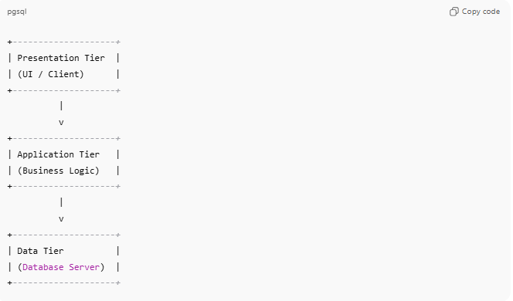
+--------------------+
| Presentation Tier |
| (UI / Client) |
+--------------------+
|
v
+--------------------+
| Application Tier |
| (Business Logic) |
+--------------------+
|
v
+--------------------+
| Data Tier |
| (Database Server) |
+--------------------+

Explanation of Each Tier
# Source: AI Source: Provided by: [Data Path: Persons Table -> ID Column: 1, Name_En Column: Motasem Essam] -> From: [ChatGPT] on [1/16/2026]
1. Presentation Tier
- User interface
- Displays data to users
- Collects user input
Examples: Web browser, mobile app, desktop UI

Application Tier
# Source: AI Source: Provided by: [Data Path: Persons Table -> ID Column: 1, Name_En Column: Motasem Essam] -> From: [ChatGPT] on [1/16/2026]
- Contains business logic
- Processes client requests
- Validates data and enforces rules
Examples: Web server, application server (Java, .NET, Node.js)

Data Tier
# Source: AI Source: Provided by: [Data Path: Persons Table -> ID Column: 1, Name_En Column: Motasem Essam] -> From: [ChatGPT] on [1/16/2026]
- Stores and manages data
- Handles database operations
Examples: MySQL, Oracle, MongoDB

How It Works
# Source: AI Source: Provided by: [Data Path: Persons Table -> ID Column: 1, Name_En Column: Motasem Essam] -> From: [ChatGPT] on [1/16/2026]
- User interacts with the presentation tier
- Request goes to the application tier
- Application tier processes logic and queries the data tier
- Result is returned back to the user

Real-World Examples
# Source: AI Source: Provided by: [Data Path: Persons Table -> ID Column: 1, Name_En Column: Motasem Essam] -> From: [ChatGPT] on [1/16/2026]
- Online shopping websites (Amazon, Flipkart)
- Banking and finance applications
- Social media platforms
- Airline reservation systems

Advantages
# Source: AI Source: Provided by: [Data Path: Persons Table -> ID Column: 1, Name_En Column: Motasem Essam] -> From: [ChatGPT] on [1/16/2026]
- Better security (database not exposed to users)
- Easy to scale each tier independently
- Easier maintenance and updates
- Improved performance for large systems

Disadvantages
# Source: AI Source: Provided by: [Data Path: Persons Table -> ID Column: 1, Name_En Column: Motasem Essam] -> From: [ChatGPT] on [1/16/2026]
- More complex than two-tier systems
- Higher development and infrastructure cost
- Slightly increased latency due to extra layer

Two-Tier vs Three-Tier (Quick Comparison)
# Source: AI Source: Provided by: [Data Path: Persons Table -> ID Column: 1, Name_En Column: Motasem Essam] -> From: [ChatGPT] on [1/16/2026]
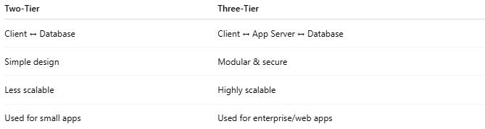
Two-Tier | Three-Tier
Client ↔ Database | Client ↔ App Server ↔ Database
Simple design | Modular & secure
Less scalable | Highly scalable
Used for small apps | Used for enterprise/web apps

Easy Analogy
# Source: AI Source: Provided by: [Data Path: Persons Table -> ID Column: 1, Name_En Column: Motasem Essam] -> From: [ChatGPT] on [1/16/2026]
- Three-Tier: Customer → Waiter → Chef
- Customer (UI) orders food, waiter (logic) manages the request, chef (database) prepares data.

